**Software Requirement Specification (SRS)**

# **Project Title: Quick Job Inc.**

## Requirements:

We need to build software for Quick Job Corporation. The application will have following features:

1. There will be five types of user like Admin, Employees, Job-seeker, Operator and Company.
2. There will be employees like manager, account manager, advertising manager and financial manager.
3. There will be login for Admin, Employees, Job-seeker, Operator and Company.
4. Admin can see and edit every table like Job Post list, Job Category list, Role list, Company list also Job-seeker list. Admin can edit data and get information of all about.
5. Operator will get short time login authentication until their job finish.
6. Employees can operate page as their specialty.
7. Company can upload a job post and how many Job-seeker applied in their company, who applied and they can also see the CV of Job-seeker.
8. Job-seeker can see who many jobs are available, what types of jobs are available, upload and create their CV and will be able to apply in jobs as their skill

## Analysis and Design:

### **Brainstorming Diagram:**

### Brainstorming Diagram 2.jpg

### **Use Case Diagram:**

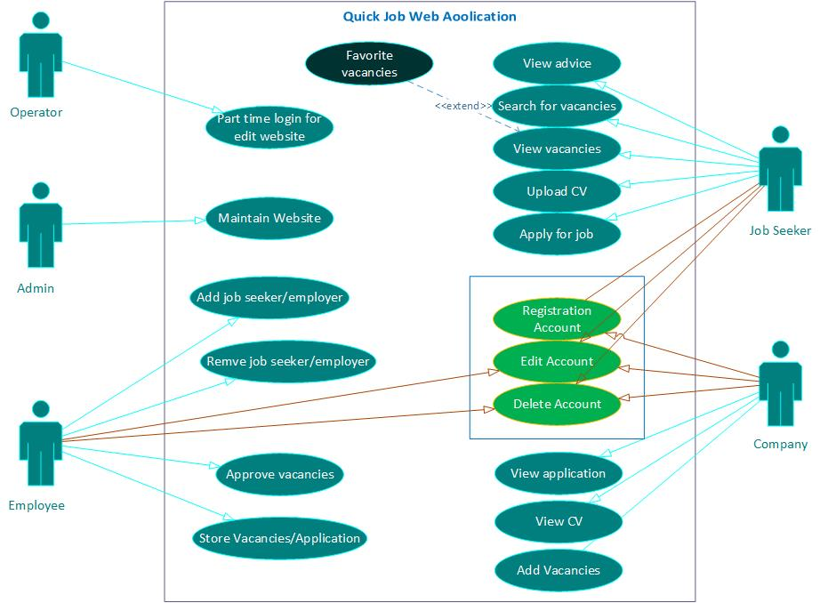

### **Class Diagram:**

